Publication bias
We assessed publication bias using funnel plots and Egger's linear regression test.
PE：The funnel plot revealed broadly symmetrical distribution of study points ( Figure1). Egger's test results did not support the presence of publication bias （P = 0.845). In summary, this meta-analysis is unlikely to be substantially affected by publication bias.
Preterm birth: The funnel plot revealed broadly symmetrical distribution of study points ( Figure 2). Egger's test results did not support the presence of publication bias (P = 0.370). In summary, this meta-analysis is unlikely to be substantially affected by publication bias.

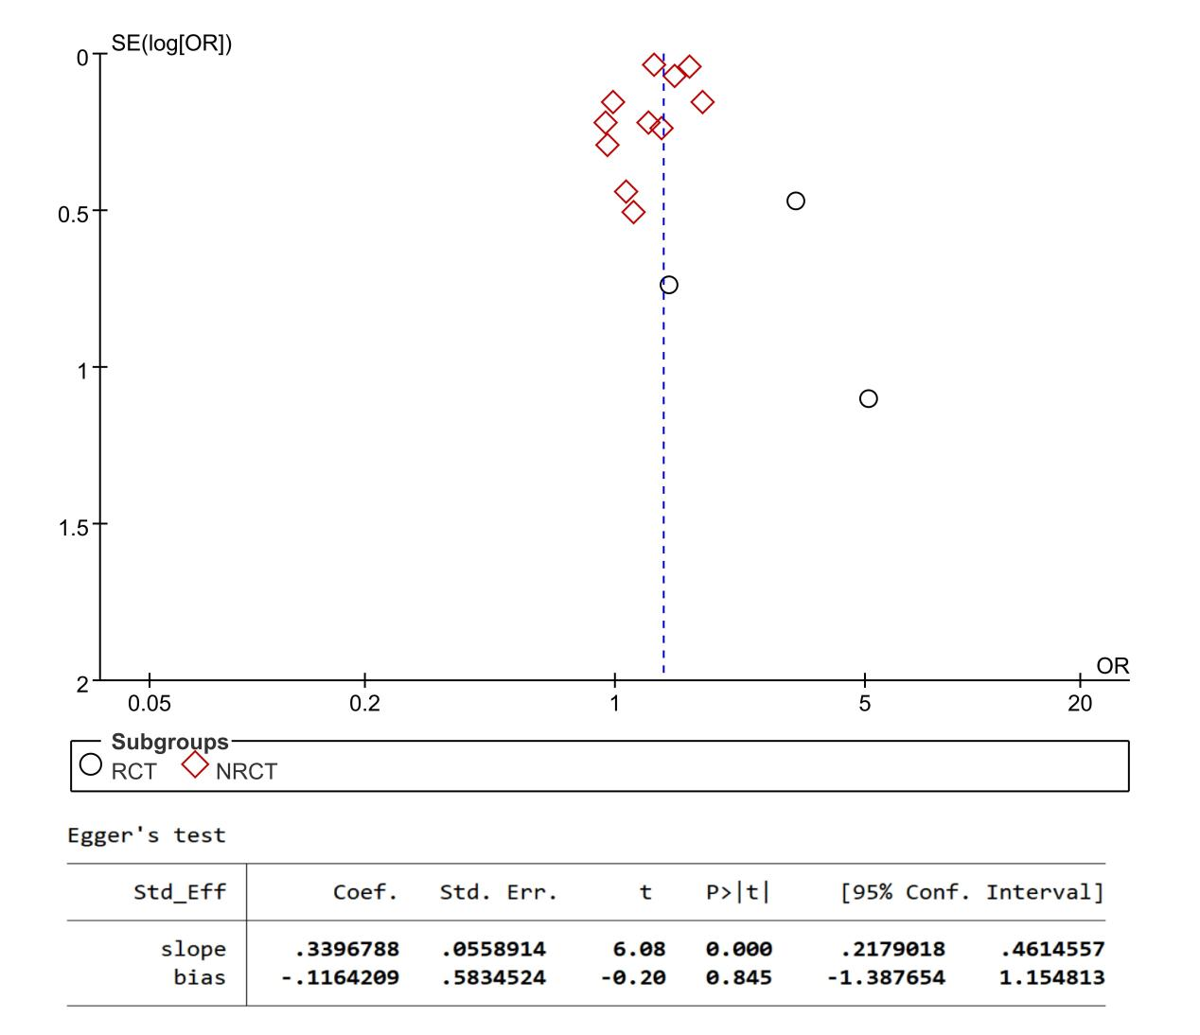

Supplementary Fig. 1.Funnel plot and Egger's test in PE

Supplementary Fig. 2 Funnel plot and Egger's test in Preterm birth

Funnel plot of placental abruption
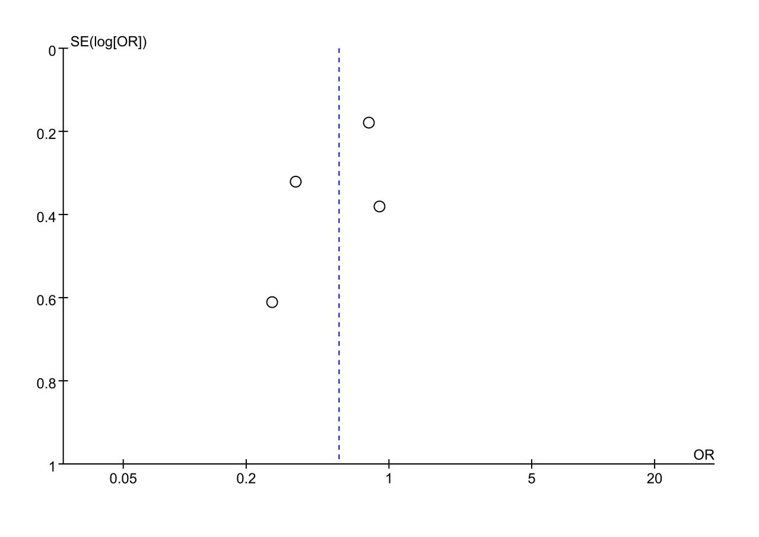
Supplementary Fig. 3 Funnel plot in placental abruption

Funnel plot of Caesarean section
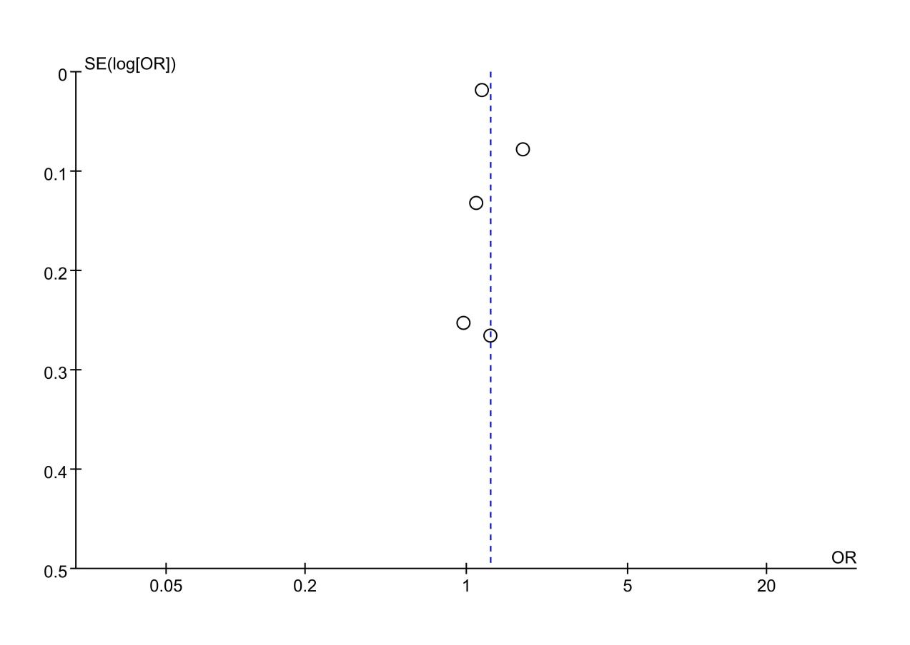
Supplementary Fig. 4 Funnel plot in Caesarean section

Funnel plot of still birth

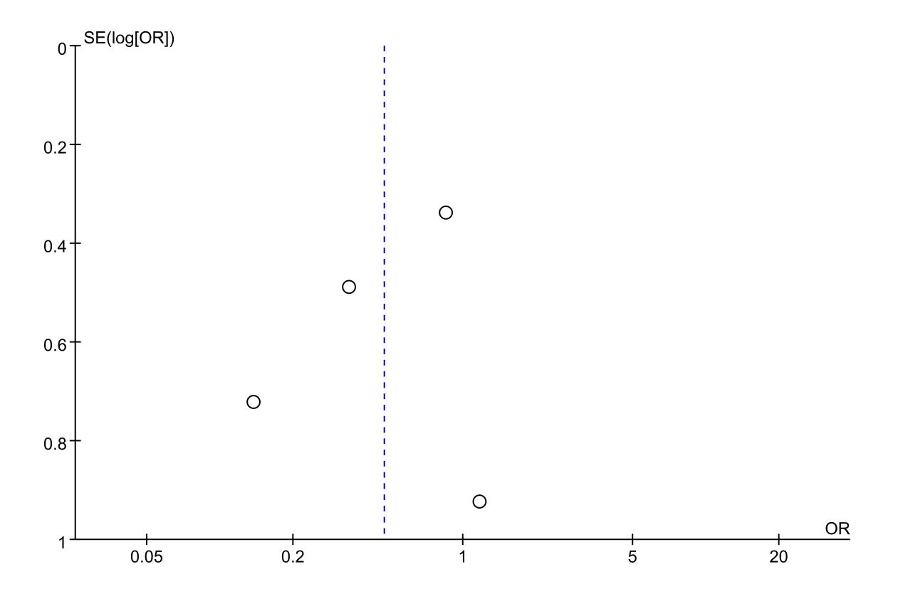
Supplementary Fig. 5 Funnel plot in still birth

Funnel plot of low birth weight
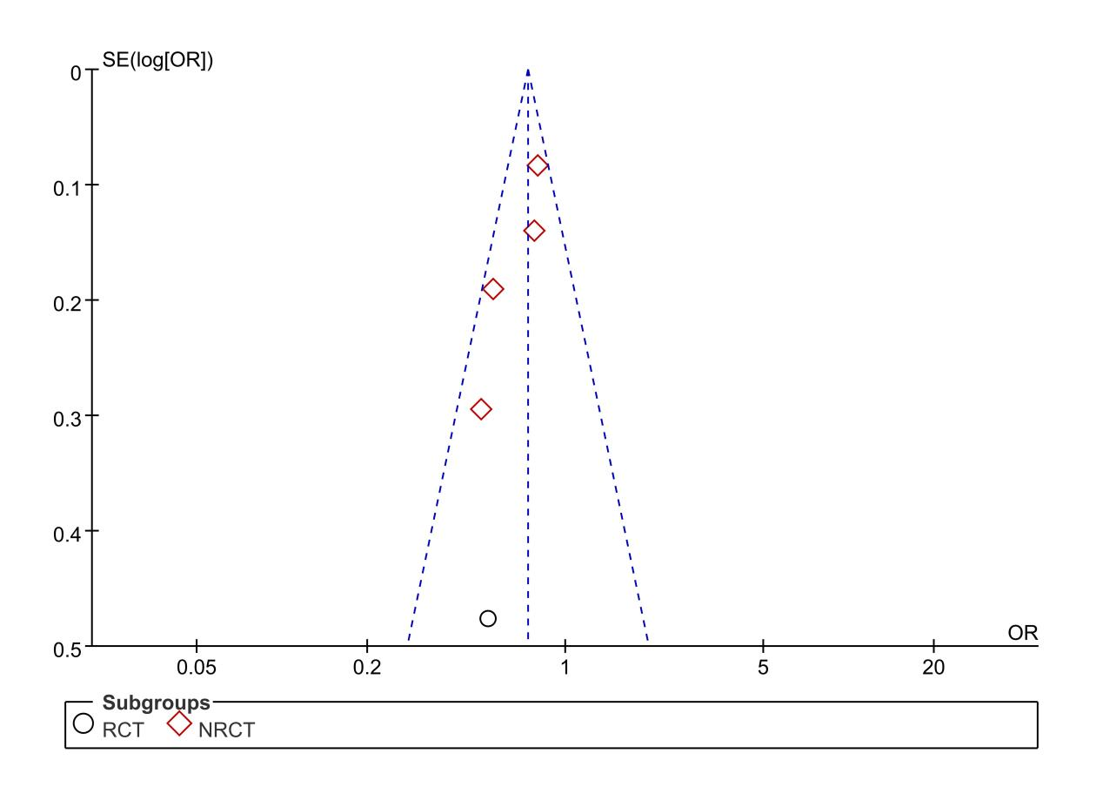
Supplementary Fig. 6 Funnel plot in low birth weight

Sensitivity analysis
We next evaluated the robustness of the meta-analysis results for the various outcomes by excluding each study in turn.
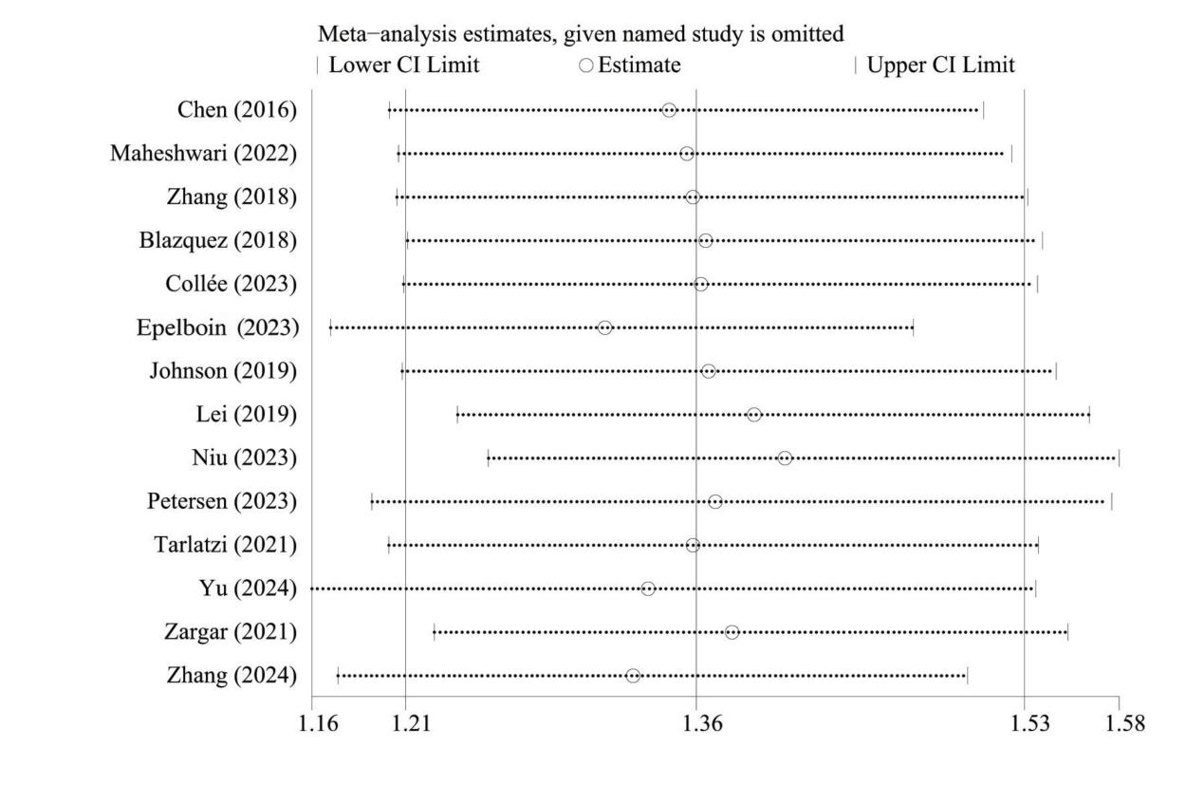

Supplementary Fig. 7. Sensitivity analysis for the risk of PE: frozen ET vs fresh ET

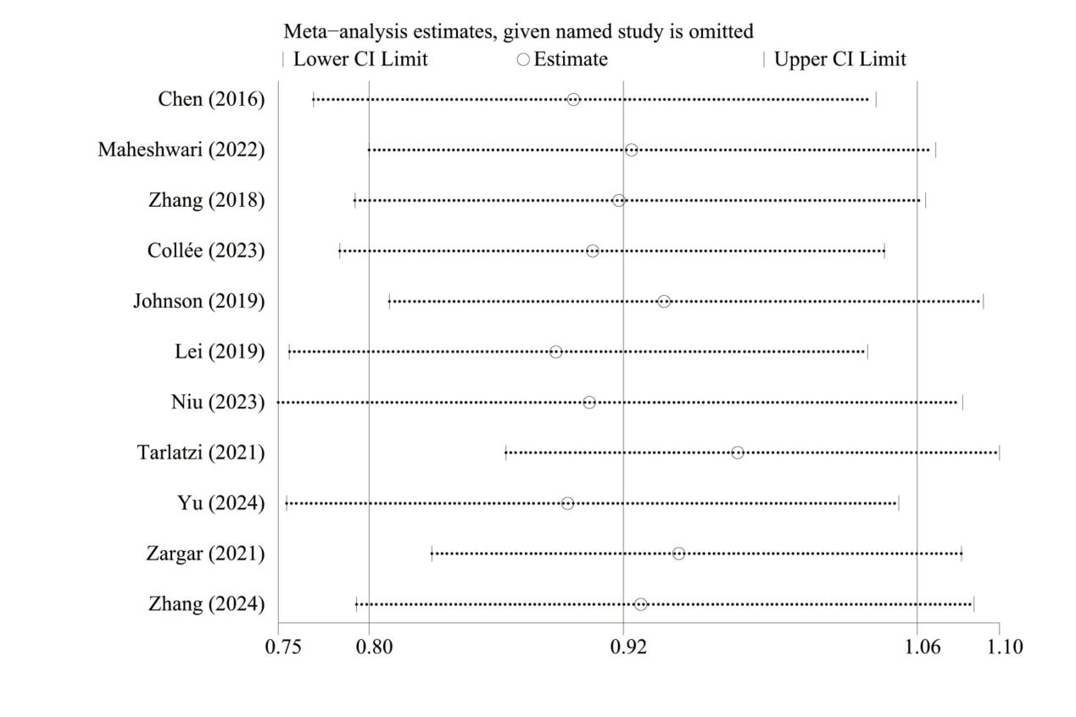

Supplementary Fig. 8. Sensitivity analysis for the risk of preterm birth: frozen ET vs fresh ET

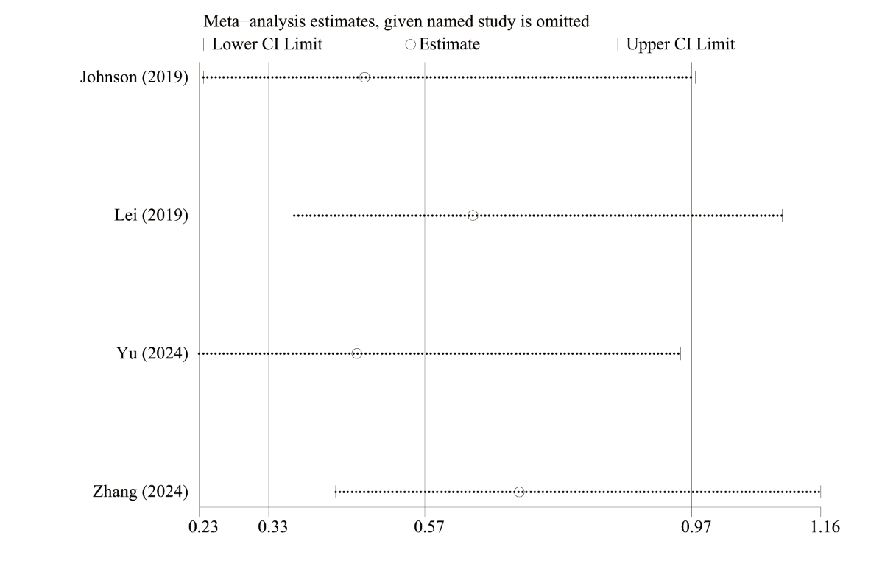

Supplementary Fig. 9. Sensitivity analysis for the risk of placental abruption: frozen ET vs fresh ET

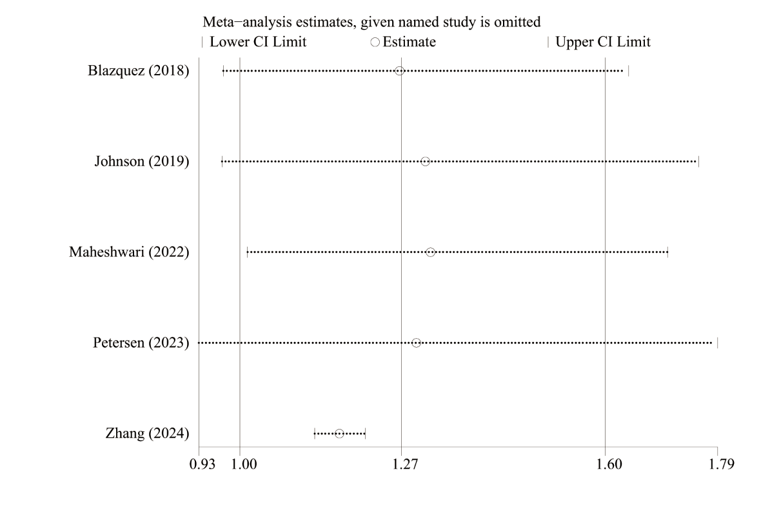

Supplementary Fig. 10. Sensitivity analysis for the risk of Caesarean section: frozen ET vs fresh ET

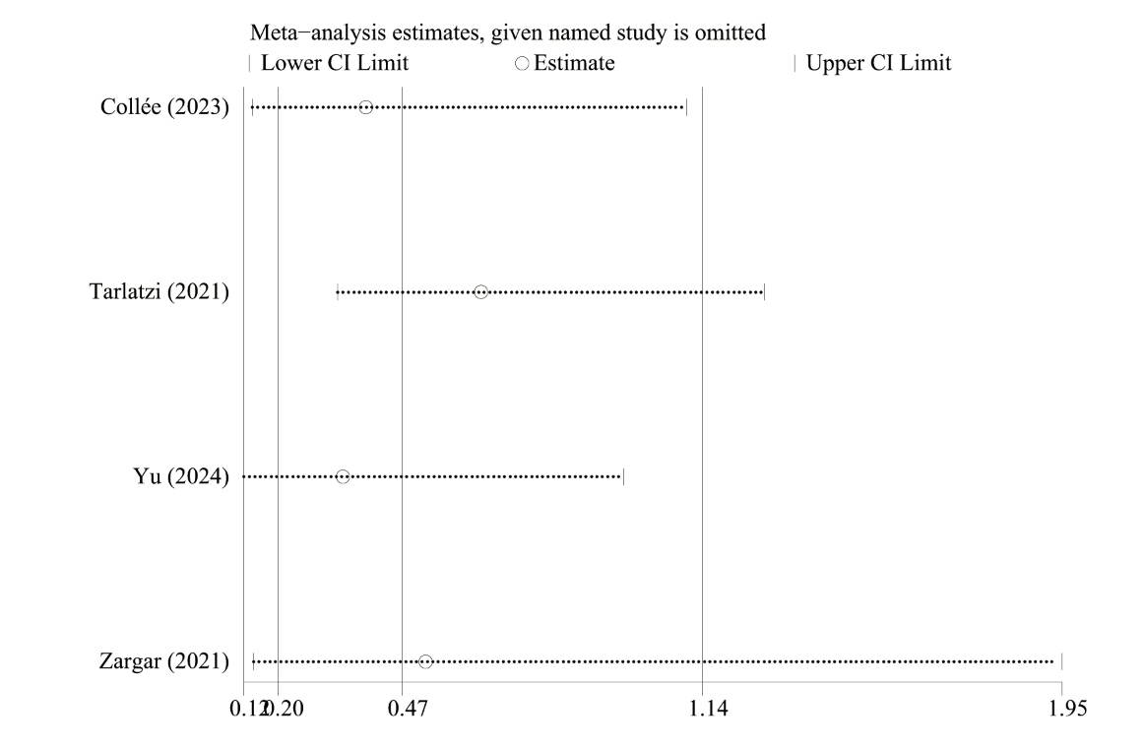

Supplementary Fig. 11. Sensitivity analysis for the risk of still birth: frozen ET vs fresh ET

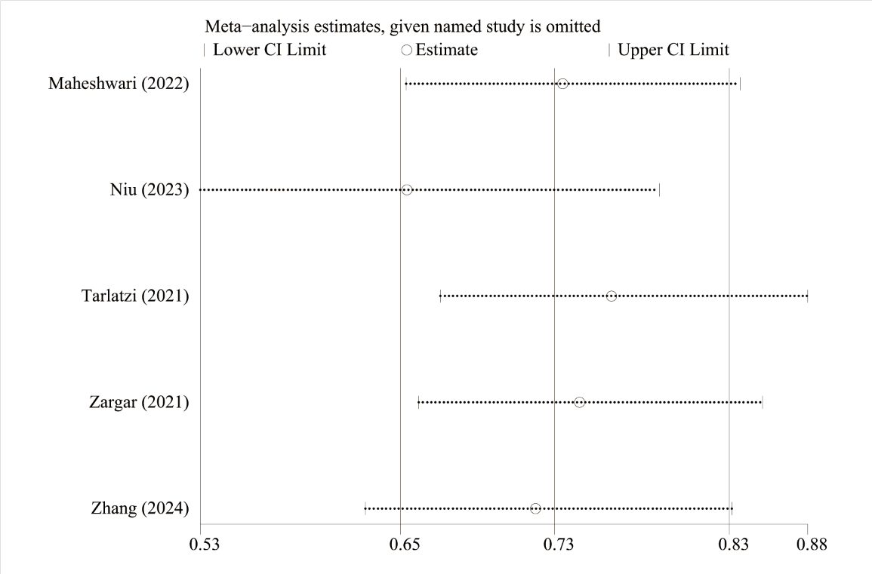

Supplementary Fig. 12. Sensitivity analysis for the risk of low birth weight: frozen ET vs fresh ET

